Use-Case Realization Report
UpdateDap

Issue <1.0>
Revision History
Date | Issue | Description | Author
<dd/mmm/yy> | <x.x> | <details> | <name>

Table of Contents
1. Brief Description 4
2. Flow of Events 4
3. Interaction Diagrams 4
3.1 Collaboration Diagram for UpdateDap 4
3.2 Sequence Diagram for UpdateDap 5
4. Participating Objects 7
5. Class Diagrams 8
5.1 Class Diagram for UpdateDap 8
6. Derived Requirements 8

Use-Case Realization Report
UpdateDap

Brief Description

Flow of Events
[enter the flow of events here; you can use subsections to structure the text]

Interaction Diagrams

Collaboration Diagram for UpdateDap
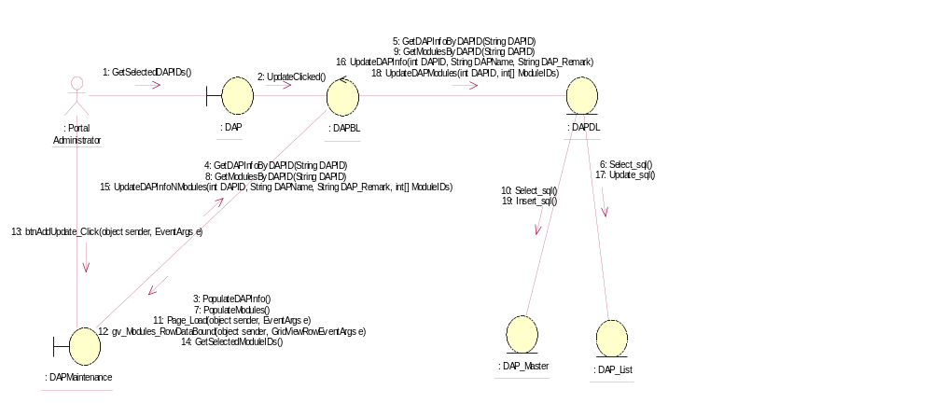

Sequence Diagram for UpdateDap
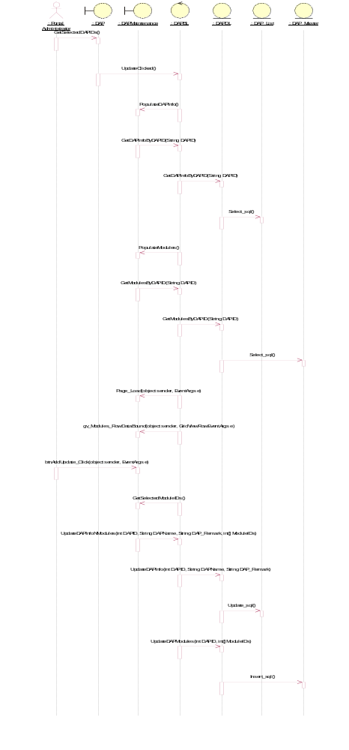

Participating Objects
: DAP

: DAP_List

: DAP_Master

: DAPBL

: DAPDL

: DAPMaintenance

: Portal Administrator

Class Diagrams

Class Diagram for UpdateDap
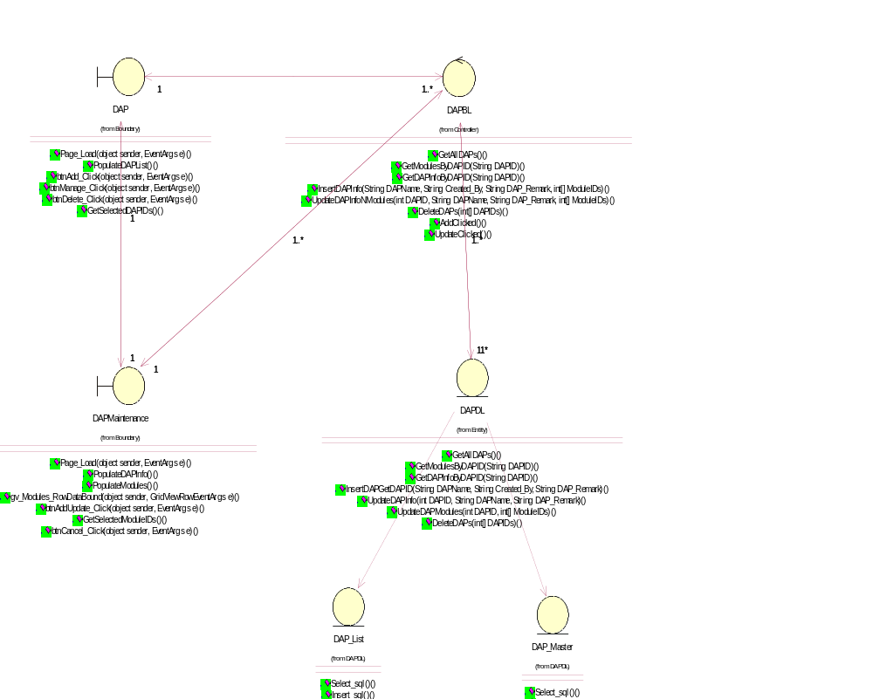

Derived Requirements
[enter the derived requirements here]

